**Name :**

**Hafsa Waseem**

**Roll no:**

**SU92-BSSEM-S24-014**

**Subject :**

**DSA (Lab)**

**Section :**

**3A**

**Submitted to:**

**Sir Rasikh**

**Task no 6:**

**Implement functions to delete the first node, last node, Nth node, and centre node of a singly linked list**.

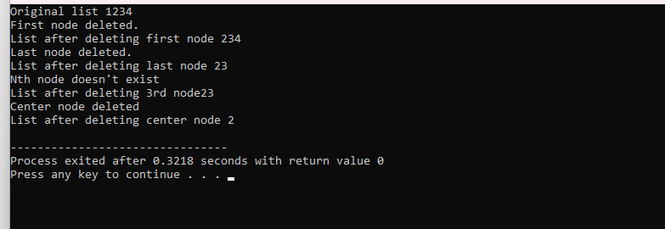

**Explanation :**

First we made a class of node then we made 6 functions (addnode,displaylist,deletenthnode,deletelastnode,deletefirstnode,deletecenternode)in the main function ,we call all the functions and display the lsit.